MINISTRY OF EDUCATION OF THE REPUBLIC OF BELARUS

Educational establishment
"Pavel Sukhoi Gomel State Technical University"

Faculty of Automated and Information Systems
Department of Information Technologies

EXPLANATORY NOTE
To term paper
By discipline
"Object-oriented design and programing"
On the topic: "Desktop application for accounting of freight and passenger transportation of a transport company"
Performer: student of group ITP-23
Kilolo Mwila Alexis
Leader: Kurochka K.S.

Check date: ___________________________________
Date of admission to protection: ___________________
Defense date: __________________________________

Evaluation of work: _____________________________ _____________________________
Commission member’s signatures
To defend the course project: __________________

Gomel 2024

table of content

Introduction

Our task is to develop a desktop application based on Windows Forms for managing car sales in a car dealership. For each car, we need to track information such as car make, model, color, year o manufacture, mileage, body type, and gearbox type. we need to record the date of sale, customer’s last name and first name, and price. we need to Generate the reports and allow saving them to a text file. This report should container a Total sales for a specified period, Sales volume grouped by car brand and body type, and Implement search functionality for cars based on year of manufacture, mileage, body type, and price. In order to realize this project we will use the following technologies: Use MS SQL DBMS and ADO access technology as the data source, Develop a user-friendly desktop application using the C# programming language, Create classes to access data powered by .NET for displaying, adding, deleting, and editing data from database tables.

I. Technology

I.1. Existing Technology in the Application

In this chapter, we will introduce the different technologies used in my application, such as the Database Manager System (DBMS), Microsoft SQL Server (MSSQL), ADO.NET and C-Sharp (C#).

I.1.1Database Management System (DBMS)

The "database management system" (DBMS) is a set of computer software that allows users to interact with one or more databases and access all the data present in them (although there may be restrictions that restrict access to certain data). The DBMS offers various features that allow for the entry, storage, and retrieval of large amounts of information, as well as ways to manage the organization.
For your information, the DBMS includes different components, each playing a crucial role in the overall system. These components include the
- Data Definition Language (DDL)
- Data Manipulation Language (DML)
- Data Query Language (DQL)
- Database Schema
- Data Dictionary
- Query Processor
- Storage Manager
- Transaction Manager.
Each component contributes to different aspects of data management, ranging from defining the database structure to processing queries and maintaining data consistency.

Key Features and Functionalities

DBMS offers a range of features and functionalities to facilitate efficient data management. Some notable features include data abstraction, data independence, concurrency control, data security, transaction management, and query optimization. These features enhance productivity, ensure data consistency, provide data access controls, enable concurrent data processing, and optimize query execution, resulting in improved performance and reliability.

Types of DBMS. DBMS can be classified into various types based on their data models and architecture. The most common types include Relational DBMS (RDBMS), Object-Oriented DBMS (OODBMS), Hierarchical DBMS (HDBMS), Network DBMS (NDBMS), and NoSQL DBMS. Each type has its own advantages and best suited for specific data management requirements, offering flexibility in terms of data modeling and data access patterns.
Based on my project, I used a relational database MS SQL Server (we will talk about it in the followed point).

Advantages or Benefits of DBMS. DBMS provides numerous benefits to organizations, making it an essential technology for efficient and reliable data management. These benefits include improved data sharing and accessibility, data consistency and integrity, data security and privacy, reduced data redundancy, increased productivity, scalability, and support for decision-making processes. DBMS enables organizations to make informed decisions based on accurate and up-to-date information, streamlines data processing workflows, and enhances collaboration among users.

Database Design and Development. The process of designing and developing a database using DBMS involves several steps, including conceptual design, logical design, and physical design. It requires understanding the organization's data requirements, determining the relationships between data entities, and translating them into a database schema. DBMS provides tools and functionalities to support these design and development processes, ensuring efficient and effective database structures.
Popular DBMS Systems. There is a wide range of DBMS systems available, each with its own strengths and use cases. Some popular DBMS systems include Oracle Database, Microsoft SQL Server, MySQL, PostgreSQL, and MongoDB. These systems cater to various data management needs, and are widely adopted in different industries and organizations worldwide.

In summary, Database Management Systems (DBMS) are integral to modern information systems, providing a structured approach to data management. They enable organizations to efficiently store, retrieve, manipulate, and manage vast amounts of data. With their range of features and functionalities, DBMS offers benefits such as improved data accessibility, integrity, security, and productivity.

What Is Microsoft SQL Server?

As a basic definition, Microsoft SQL Server is a Related Database Management System (RDBMS) that runs on the SQL programming language. It has the capacity to support a huge variety of transaction processing applications as well as business intelligence and analytics in corporate IT environments.
The RDBMS gives you the advantage of working with a table structure based on rows, which allows you to connect data elements and functions. Unlike a Database Management System (DBSM), it enables you to maintain the security, integrity and consistency of the data you’re working with

Why did I Choose MSSQL? Well, MSSQL server is an incredibly popular database solution used today, and one of its strongest advantages is its ease of use. MSSQL comes with many excellent tools, which make database development a fast and agile process. SQL Server management studio allows any approved user to manage and maintain the databases, run SQL queries, perform backups and analyze performance charts. MSSQL integrates with Visual Studio to give your DevOps team a powerful, familiar platform to create and manage custom applications that seamlessly integrate with MSSQL Server.
MSSQL Main Features. MySQL follows a client-server architecture, where the database server handles data storage, retrieval, and processing, while clients interact with the server to perform operations on the database. The clients can be command-line interfaces, graphical user interfaces (GUIs), or applications developed using programming languages.
It offers a wide range of storage engines, including the default InnoDB engine, which provides support for transactions and referential integrity. Other storage engines like MyISAM, MEMORY, and ARCHIVE offer specific optimizations for different types of applications and use cases.
The ability to choose the appropriate storage engine based on specific requirements allows developers to optimize performance and reliability.
MySQL provides various features to ensure data integrity and security. It supports transactions, which allow multiple database operations to be treated as a single unit of work, ensuring that changes are applied either completely or not at all. MySQL also offers robust authentication and access control mechanisms, allowing administrators to define user accounts and assign different privileges and permissions to ensure data security.
Additionally, MySQL offers scalability features that allow it to handle large amounts of data and high traffic volumes. It supports replication, where data is automatically synchronized across multiple servers, enabling load balancing and high availability. MySQL also provides partitioning capabilities, allowing large tables to be divided into smaller, more manageable partitions for improved performance.
Furthermore, MySQL has a vibrant and active community that contributes to its development and provides extensive support and resources. This community-driven approach has resulted in a rich ecosystem of plugins, extensions, and frameworks that enhance the functionality and usability of MySQL.
There are many products, which make up the SQL Server database platform, but there are 4 key services built into MSSQL which define it and make it a popular choice as a database management system (DBMS). These options are available to install when deploying the MSSQL instance. The latest releases of MSSQL are not just compatible with Windows; more recently, Microsoft has offered SQL for Linux (Red hat and SUSE), as well as Docker container platforms.
In conclusion, I can say that MSSQL Server is one of the best database solutions available today in the SQL marketplace. If you are looking for a secure, easy to manage and high-performance database management system for your compliant database, then MSSQL should be a serious option to consider, it enables users to analyze data, forecast sales and even predict customer behavior using business intelligence analytics.

I.1.2. Difference between MS SQL Server and MySQL

Let us make a difference between MS SQL Server and MySQL in order to enlighten this topic.
Microsoft SQL Server (MS SQL Server) and MySQL are both relational database management systems (RDBMS), but they have significant differences in terms of their features, licensing, and target user base:

I.1.3. Ownership and Licensing

Microsoft SQL Server: MS SQL Server is a product developed and owned by Microsoft. It is a commercial database management system that requires purchasing a license for its use. Microsoft offers different editions of SQL Server, ranging from the free Express edition to the more advanced Enterprise edition.

MySQL: MySQL is an open-source RDBMS that is managed by Oracle Corporation. It is released under the GNU General Public License (GPL) and offers a community edition that is free to use. There is also a commercial version called MySQL Enterprise Edition that provides additional features and support services.

I.1.4 Features and Functionality

Microsoft SQL Server. MS SQL Server is known for its comprehensive set of features, including robust security measures, advanced analytics and reporting capabilities, high availability and scalability options, integration with Microsoft development tools, and support for business intelligence (BI) features.

MySQL. MySQL is focused on simplicity, performance, and reliability. It provides essential RDBMS features, such as data integrity, transaction support, and ACID compliance. MySQL is often favored for its ease of use, fast performance, and suitability for web-based applications and small to medium-sized databases.

I.1.5 Target User Base

Microsoft SQL Server. MS SQL Server is widely used in enterprise environments and larger organizations where complex database requirements, scalability, and integration with Microsoft technologies are important. It is often preferred for mission-critical applications, data warehousing, and large-scale data processing.

MySQL. MySQL is popular among developers, startups, and small to medium-sized businesses due to its ease of use, affordability, and compatibility with various programming languages and platforms. It is commonly used in web applications, content management systems, and projects where simplicity and speed are valued.

Ecosystem and Community

Microsoft SQL Server. MS SQL Server has a strong ecosystem and a large community of users. It offers extensive documentation, official support channels, and a range of tools and resources for developers and administrators.

MySQL. MySQL also has a vibrant and active community, with a wealth of online resources, forums, and community-driven support available. It has a wide range of third-party tools and libraries that integrate well with different programming languages.
So according to my project, I used MS SQL DBMS, because It is important to consider the specific requirements, budget (if needed), and technical expertise of your project when choosing between MS SQL Server and MySQL. Both database management systems have their strengths and are suitable for different use cases, so it is essential to evaluate your needs and priorities before making a decision.

ADO.NET

In order to communicate with various data source such as SQL Server, MySQL , XML and more we are going to use one of Microsoft’s Data Access called Ado.net. Thanks to this techonologie we are able not just to connect but also to make various operation such as read, add or insert , edit or update and delete data from our source.
ADO.NET is compose of classes that expose data access services for .NET Framework programmers. ADO.NET provides a rich set of components for creating distributed, data-sharing applications (DataReader , ...).

What is a Providers?

Well, the database can't directly run our C# code, it only includes SQL. So, if a application .NET needs to retrieve data or perform insert, edit, and delete operations from or to a database, then the .NET application must:
- Connect to the Database
- Prepare an SQL Command
- Execute the Command
- Retrieve the results and display them in the application.
And this is possible with the help of .NET Data Providers.
The main namespaces used in ADO.NET are:
System.Data: Defines the classes, interfaces, delegates that implement the ADO.NET architecture
System.Data.Common: Contains classes that are common to all providers ADO.NET
System.Data.Design: Defines the classes used to create their own datasets
System.Data.Odbc: Defines the data provider capabilities for ODBC
System.Data.OleDb: Defines the data provider capabilities for SQL Serve

How to Connect ADO.NET Code with SQL Server Database

Accessing a database file requires a string connection. It contains information about the server you will be connecting, the database you will need to use, and the credentials you can use to connect. Each database has its own characteristics, including the name and type of the server. The SqlConnection class represents a database link. In this connection string,
- Server – Name of the server to connect to.
- Database – The name of the database you are connecting to.
In all of the databases, there are two types of login methods. Windows Authentication and Database Authentication.
In our case we are using a Windows Authentication, so the the identification will be completed by our operating system windows.In second case, the authentication(user name and passe word) and the Trusted Connection part will be require inside the connection string.
From System.Data.SqlClient namespace some pre-established (pre-define) classes are used, such as SQLConnection, SQLCommand, and SQLDataReader. This class is referred to as fournisseur (Provider.NET) classes and is responsible for interacting with the database.

Some word about Csharp (C#)
C# was designed by Anders Hejlsberg from Microsoft in 2000 , and has since gained popularity among developers and organizations worldwide. It is a multi-paradigm language that combines elements of object-oriented programming (OOP) with modern . C# is particularly popular for developing applications on the Microsoft platform. Developed by Microsoft within the .NET framework. C# is widely used for developing various types of applications such as:
- Mobile applications
- Desktop applications
- Web applications
- Web services
- Web sites
- Games
- Database applications , And much more!

II. Project Architecture

Architecture and logic of the application
Windows Forms is a popular framework for building desktop applications in C#. It provides a rich set of controls and components that enable developers to create functional and visually appealing user interfaces. When designing a Windows Forms application, it is important to consider the architecture and logic of the application to ensure that it is scalable, maintainable, and easy to understand.

One key aspect of Windows Forms application architecture is the separation of concerns. This means dividing the application into distinct layers or components, each responsible for a specific aspect of the application's functionality. One common approach is to use the Model-View-Controller (MVC) pattern, where the Model represents the data, the View represents the user interface, and the Controller acts as an intermediary between the two.

In a typical Windows Forms application, the Model layer may consist of classes that represent data entities, such as customer or product objects. These classes can contain properties and methods to manipulate the data and communicate with the database or other data sources. The View layer consists of the user interface elements, such as forms, controls, and dialogs, that allow users to interact with the application. The Controller layer contains the business logic that coordinates interactions between the Model and View layers.

Another important aspect of Windows Forms application architecture is event-driven programming. In Windows Forms, user interactions and system events such as button clicks, key presses, and form resizing trigger events that can be handled by event handlers. Event handlers are methods that are executed in response to specific events and are used to update the user interface, process data, or perform other actions.

To maintain a clear and organized code structure, it is important to properly organize event handlers and other code logic in the application. One common approach is to group related code into separate classes or modules based on their functionality. For example, you may have a separate class to handle database operations, another class for business logic, and yet another class for user interface interactions.

In addition to organizing code effectively, it is also important to write clean and maintainable code. This includes following best practices such as using meaningful variable and method names, avoiding code duplication, and properly commenting code to explain its purpose and functionality. By writing clean code, developers can easily understand and modify the application in the future, reducing the risk of introducing bugs or breaking existing functionality.

In terms of user interface design, Windows Forms provides a wide range of controls and components that can be used to create intuitive and user-friendly interfaces. Developers can use controls such as buttons, textboxes, labels, and listboxes to build interactive user interfaces that match the requirements of the application. It is important to carefully design the layout and navigation of the user interface to ensure a seamless and enjoyable user experience.

Overall, designing the architecture and logic of a Windows Forms application in C# requires careful planning and attention to detail. By following best practices such as separating concerns, organizing code effectively, and writing clean code, developers can create robust and well-structured applications that meet user requirements and are easy to maintain and extend.

II.1.1 User Interface (UI)

User Interface (UI) in Windows form applications is a critical aspect of any software's design and functionality. In the realm of software development, the user interface serves as the point of interaction between the user and the application. It encompasses elements such as buttons, menus, text fields, sliders, and any visual or interactive components that enable users to interact with and control the software.

The definition of User Interface (UI) in the context of Windows form applications refers to the visual layout and design of the graphical user interface (GUI) elements that users interact with on the screen. It involves the arrangement of controls, the choice of colors and fonts, and the overall user experience provided by the application.

- Model
The Model component represents the core business logic and data of your application. It encapsulates the rules, operations, and behaviors related to the application's domain. The Model layer typically consists of classes, objects, and methods that model the entities and operations within the application.
Define the Model layer, which represents the core business logic and data structures. Identify the entities, relationships, and operations required for your application. Design the classes, objects, and methods that model the application's domain.

- Object-Relational Mapping (ORM)
In computer science, object-relational mapping (or ORM, O/RM, and O/R) is a programming method that transforms data between a relational database and the stack of an object-oriented programming language. Effectively, this generates a database of virtual objects that can be exploited from the SQL language.
Examples:
- Entity Framework for .NET applications(present in our project)
- Hibernate for Java applications
- or SQLAlchemy for Python applications.

- Database

The Database component represents the storage and retrieval of data. It includes the actual database system where the data is stored, such as MySQL, Microsoft SQL Server, PostgreSQL, or Oracle. The database stores the data in a structured manner and provides mechanisms for querying and modifying the data.
Determine the database system (DB) that aligns with your application's needs, taking into account factors like scalability, performance, and data requirements. Design the database schema, tables, and relationships to store the application's data efficiently.

II.1.2 Database Structure

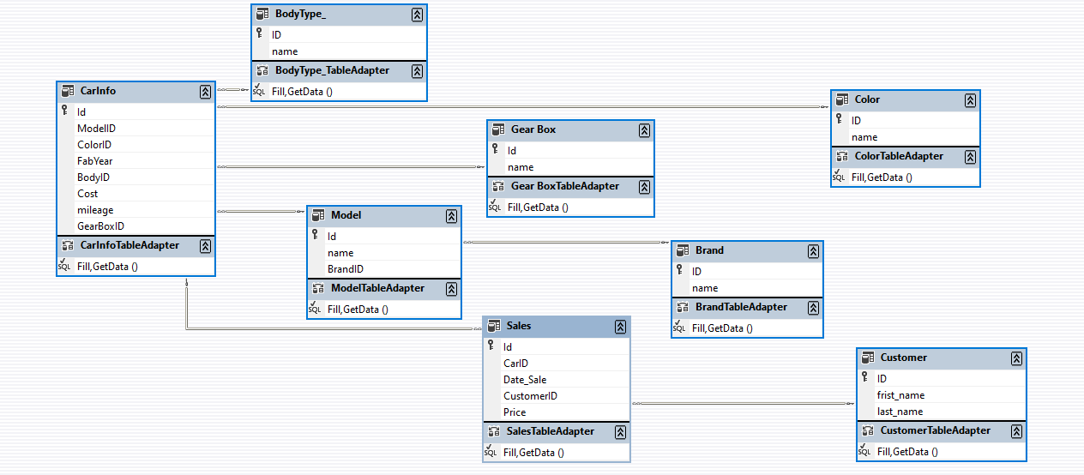

- Tables Structure

- CarInfo:
Id: Primary key representing the Car's unique identifier
Cost: Represent the price.
ModelID: Foreign key referencing the model’s table, indicating the car’s model
ColorId: Foreign key referencing the color’s table, indicating the car’s color
BodyID : Foreign key referencing the body’s table, indicating car’s body Type
Mileage: represent how many the kilometers the car going to run per litre of fuel
cost: price
FabYear: represent the year of release
- Customer
ID: primary key represent a unique identifier of Customer
First_name and Last_name represent the first and last name of customer
- gearbox
ID: primary key represent a unique identifier of gearbox
name: represent the gear box type
- Brand
ID: primary key represent a unique identifier of brand
name: represent the brand
- Model
ID: primary key represent a unique identifier of Model
name: the model name
BrandID: Foreign key referencing the car’s brand
- Sales
ID: primary key represent a unique identifier of sales
customerID: foreign key referencing the customer
CarID: foreign key referencing the CarInfo table
Date_Sale: represent the date of sale
price: price
- color
ID: primary key represent a unique identifier of color
name: represent the color name

II.1.3 Type of Relationships between Tables
- One-to-Many Relationship

- Sale to customer
The relationship between “Sale” and “customer” is a one-to-many relationship, where each Sale has one Destination, but each Destination can be associated with multiple customer.

- Sale to CarInfo
The relationship between “Sale” and “CarInfo” is a one-to-many relationship, where each Sale has one Destination, but each Destination can be associated with multiple CarInfo.

- CarInfo to Model
The relationship between “CarInfo” and “Model” is a one-to-many relationship, where each CarInfo has one Model, but each Model can be associated with multiple CarInfo.

- CarInfo to Color
The relationship between “CarInfo” and “Color” is a one-to-many relationship, where each CarInfo has one Color, but each Color can be associated with multiple CarInfo

- CarInfo to Gear box
The relationship between “CarInfo” and “Gear box” is a one-to-many relationship, where each CarInfo has one Gear box, but each Gear box can be associated with multiple CarInfo.

- Model to Brand
The relationship between “Model” and “Brand” is a one-to-many relationship, where each Model has one Brand, but each Brand can be associated with multiple Model
.
Testing

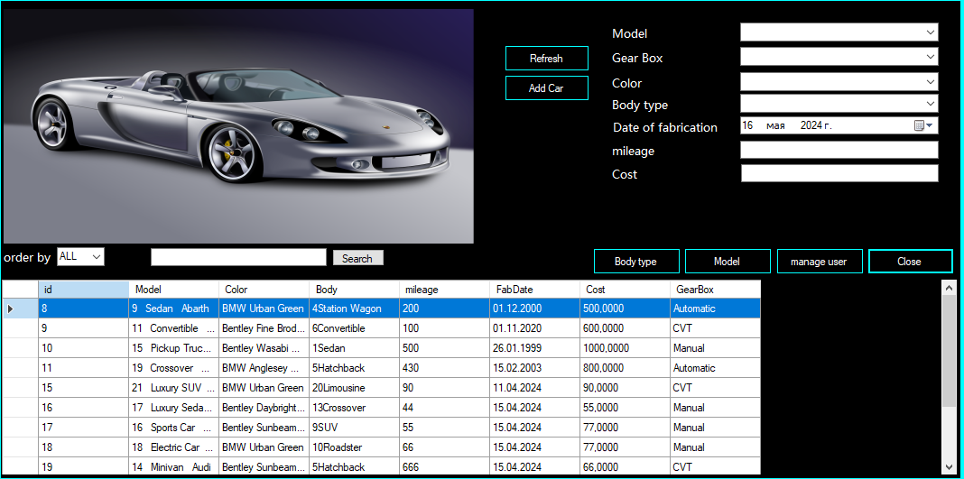
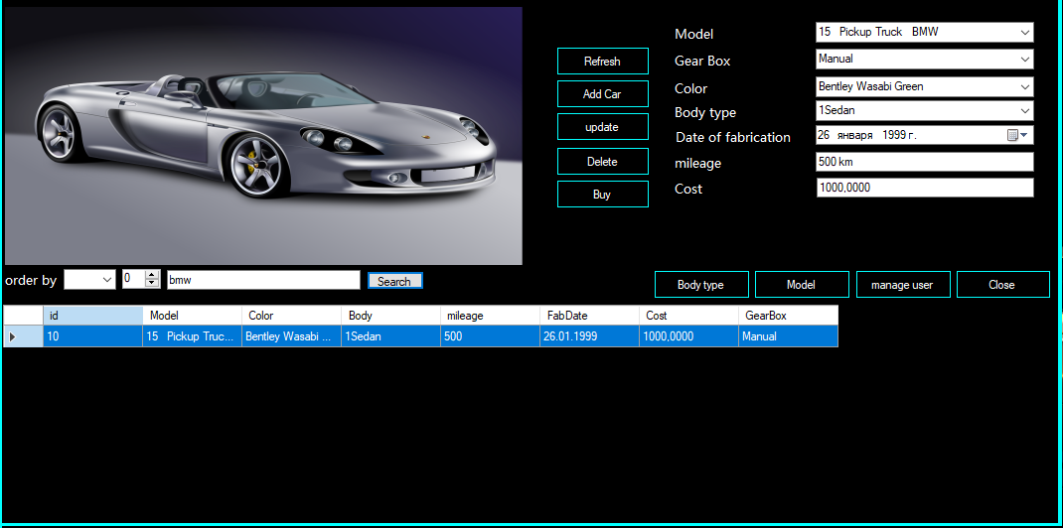

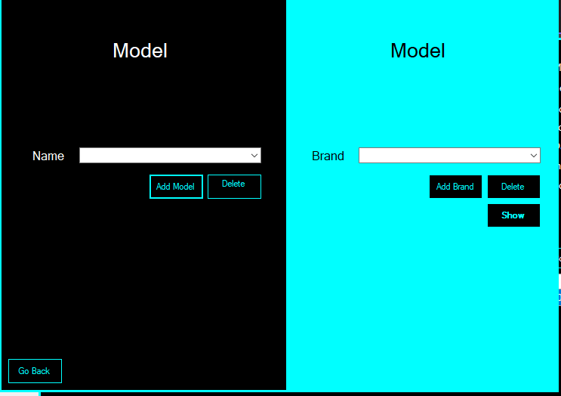

Conclusion
In the realm of software development, particularly when dealing with Windows Forms applications, the significance of a well-constructed user interface (UI) cannot be overstated. The UI acts as the bridge between the user and the application’s functionality, serving as the primary touchpoint through which all interactions occur. It is the lens through which users view the application, and its design and usability are paramount in shaping the user experience (UX). A UI that is thoughtfully designed with the user’s needs in mind can greatly enhance the effectiveness of the software and contribute to its overall success.
The user interface in Windows Forms applications is more than just a collection of buttons, text boxes, and menus. It is the embodiment of the application’s purpose and the means by which users achieve their objectives. By focusing on key usability principles such as intuitive design, responsiveness, consistency, and accessibility, developers can craft applications that stand out in a crowded marketplace. A well-designed UI not only enhances user satisfaction and productivity but also plays a critical role in the application’s adoption and success. As such, the UI should be approached with the care and attention it deserves, ensuring that it aligns with the goals of the software and the needs of its users.

Reference
- wikipedia
- metanite

Listing
using System;
using System.Collections.Generic;
using System.Data.SqlTypes;
using System.Linq;
using System.Text;
using System.Threading.Tasks;
using static System.Net.Mime.MediaTypeNames;

namespace Carlib
{
public class CarInfo
{
public int id { get; set; }
public Model Model { get; set; }
public Color Color { get; set; }
public BodyType Body{ get; set; }
public double mileage { get; set; }
public DateTime FabDate { get; set; }
public decimal Cost { get; set; }
public GearBox GearBox { get; set; }
// public Image Image { get; set; }
public CarInfo(int Id,Model model, Color color, BodyType body, double mileage, DateTime fabDate, decimal cost, GearBox gearBox)
{
id = Id;
Model = model;
Color = color;
Body = body;
this.mileage = mileage;
FabDate = fabDate;
Cost = cost;
GearBox = gearBox;
}

public CarInfo( Model model, Color color, BodyType body, double mileage, DateTime fabDate, decimal cost, GearBox gearBox)
{

Model = model;
Color = color;
Body = body;
this.mileage = mileage;
FabDate = fabDate;
Cost = cost;
GearBox = gearBox;
}

public override string ToString()
{
return $"{Model.Brand.Name}\t{Color.Name}\t{ Model.Name}\t{GearBox}\t{Cost}\t{mileage}\t{FabDate}\n ";
}

}
}

using System;
using System.Collections.Generic;
using System.Linq;
using System.Text;
using System.Threading.Tasks;

namespace Carlib
{
public class Customer
{
public int Id { get; set; }
public string FirstName { get; set; }
public string LastName { get; set; }
public Customer(int id, string firstName, string lastName)
{
this.Id = id;
FirstName = firstName;
LastName = lastName;
}
public Customer( string firstName, string lastName)
{

FirstName = firstName;
LastName = lastName;
}

public override string ToString()
{
return $"{FirstName} {LastName}";
}
}
}

using System;
using System.Collections.Generic;
using System.Data.SqlTypes;
using System.Linq;
using System.Text;
using System.Threading.Tasks;

namespace Carlib
{
public class Sales
{
public int Id { get; set; }
public CarInfo Car { get; set; }
public decimal Price { get; set; }
public DateTime Date { get; set; }
public Customer Customer { get; set; }
public Sales(int Id,CarInfo car, decimal price, DateTime date, Customer customer)
{
this.Id = Id;
Car = car;
Price = price;
Date = date;
Customer = customer;
}
public Sales( CarInfo car, decimal price, DateTime date, Customer customer)
{

Car = car;
Price = price;
Date = date;
Customer = customer;
}

public override string ToString()
{
return $"congratulation {Customer.FirstName} buy a {Car.Color} {Car.Model.Brand.Name} at {Price}";
}
}
}

using System;
using System.Collections.Generic;
using System.Linq;
using System.Text;
using System.Threading.Tasks;

namespace Carlib
{
public class BodyType
{
public int ID { get; set; }
public string Name { get; set; }
public BodyType(int id,string name)
{
ID = id;
this.Name = name;
}
public BodyType( string name)
{
this.Name= name;
}
public override string ToString()
{
return $"{ID}{Name}";
}
}
}

using System;
using System.Collections.Generic;
using System.Linq;
using System.Text;
using System.Threading.Tasks;

namespace Carlib
{
public class Brand
{
public int ID { get; set; }
public string Name { get; set; }
public Brand(int Id,string name)
{
ID = Id;
Name = name;
}
public Brand( string name)
{

Name = name;
}
public override string ToString()
{
return $"{ID} {Name}";
//$"{ Name }";
}
}
}

using System;
using System.Collections.Generic;
using System.Linq;
using System.Runtime.Remoting.Messaging;
using System.Text;
using System.Threading.Tasks;

namespace Carlib
{
public class Color
{
public string Name { get; set; }
public int ID { get; set; }
public Color(int Id,string name)
{
ID = Id;
Name = name;
}
public Color (string name)
{
Name = name;
}
public override string ToString()
{
return $"{Name}";
}
}
}

using System;
using System.IO;
using System.Collections.Generic;
using System.Linq;
using System.Text;
using System.Threading.Tasks;
using System.Reflection;
using Newtonsoft.Json;

namespace Carlib
{
public class Document
{
//read and write from or to a file
public string pathFile { get; set; } = @"C:\Users\HP\Documents\c# all resolt\rentCar\DataFile\";

public Document(string Namefile)
{
this.pathFile = Namefile;
}

public Document()
{
this.pathFile += "saveFile.txt";
}

public void Save(List<Sales> objectToSave)
{
try
{
using (StreamWriter sw = new StreamWriter(this.pathFile))
{
sw.Write(JsonConvert.SerializeObject(objectToSave, Newtonsoft.Json.Formatting.Indented));
}
}
catch (Exception err)
{
Console.WriteLine(err.Message);
}
}

//public void archive(Sales sales)
//{
// throw new NotImplementedException();
//}
//public void PrintReceipt(Sales sales)
//{
// archive(sales);
// throw new NotImplementedException();
//}
}
}

using System;
using System.Collections.Generic;
using System.Linq;
using System.Text;
using System.Threading.Tasks;

namespace Carlib
{
public class GearBox
{
public int ID { get; set; }
public string Name { get; set; }
public GearBox (int ID, string name)
{
this.ID = ID;
Name = name;
}
public GearBox( string name)
{
Name = name;
}

public override string ToString()
{
return $"{Name}";
}
}
}

using System;
using System.Collections.Generic;
using System.Linq;
using System.Text;
using System.Threading.Tasks;

namespace Carlib
{
public class Model
{
public int ID { get; set; }
public string Name { get; set; }
public Brand Brand { get; set; }
public string Image = "D:\\BestSale\\BestSale\\img\\sports-car-races-through-dark-blurred-motion-generative-ai.png";

public Model(int ID, string name,Brand brand)
{
this.ID = ID;
this.Name = name;
Brand = brand;
}
public Model( string name, Brand brand)
{
Name = name;
this.Brand = brand;
}
public override string ToString()
{
return $"{ID} {Name} {Brand.Name}";
}
}
}

using System;
using System.Windows.Forms;

using System.Collections.Generic;
using System.Configuration;
using System.Data.SqlClient;
using System.Linq;
using System.Text;
using System.Threading.Tasks;
using System.Data;
using System.Xml.Linq;
using System.Net.Cache;
using System.Security.Cryptography;
using System.Reflection;
using System.Runtime.ConstrainedExecution;

namespace Carlib
{
public class ORM
{
private static string cnnString = ConfigurationManager.ConnectionStrings["BestSale.Properties.Settings.SaleCarDBConnectionString"].ToString();
private SqlConnection cnn = new SqlConnection(cnnString);

public List<Brand> GetBrands()
{
List<Brand> Brands = new List<Brand>();
cnn.Open();
string Request = "select * from dbo.Brand";
SqlCommand cmd = new SqlCommand(Request, cnn);
SqlDataReader Reader = cmd.ExecuteReader();
if (Reader.HasRows)
{
while (Reader.Read())
{
Brand Brand = new Brand(Reader.GetInt32(0), Reader.GetString(1));
Brands.Add(Brand);
}
}
cnn.Close();
return Brands;
}
public List<BodyType> GetBodies()
{
List<BodyType> Bodies = new List<BodyType>();
cnn.Open();
string Request = "select * from dbo.BodyType_ ";
SqlCommand cmd = new SqlCommand(Request, cnn);
SqlDataReader Reader = cmd.ExecuteReader();
if (Reader.HasRows)
{
while (Reader.Read())
{
BodyType body = new BodyType(Reader.GetInt32(0), Reader.GetString(1));
Bodies.Add(body);
}
}
cnn.Close();
return Bodies;

}
public List<CarInfo> GetCarInfos(string OrderBy)
{
List<CarInfo> Cars = new List<CarInfo>();
cnn.Open();
string Request = "select c.Id,bd.ID,bd.name,cl.id,cl.name,m.Id,m.name,b.name,b.ID,c.mileage,c.FabYear,g.name" +
",g.Id,c.Cost from dbo.CarInfo c\r\ninner join BodyType_ bd " +
"on c.BodyID = bd.ID\r\ninner join Color cl on c.ColorID = cl.ID\r\n" +
"inner join Model m on c.ModelID = m.Id\r\ninner join [Gear Box] g on c.GearBoxID =g.Id\r\n" +
"inner join Brand b on m.BrandID= b.ID\r\n";
switch (OrderBy)
{
case "Date":Request += "ORDER BY FabYear";
break;
case "Brand": Request += "ORDER BY BrandID";
break;
case "Price": Request += "ORDER BY Cost";
break;
case "Model": Request += "ORDER BY Model";
break;
default: Request += " ";
break;
}
SqlCommand cmd = new SqlCommand(Request, cnn);
SqlDataReader Reader = cmd.ExecuteReader();
if (Reader.HasRows)
{
while (Reader.Read())
{
CarInfo Car = new CarInfo(Reader.GetInt32(0),
new Model(Reader.GetInt32(5), Reader.GetString(6), new Brand(Reader.GetInt32(8), Reader.GetString(7))),
new Color(Reader.GetInt32(3), Reader.GetString(4)),
new BodyType(Reader.GetInt32(1), Reader.GetString(2)),
Reader.GetDouble(9), Reader.GetDateTime(10), Reader.GetDecimal(13),
new GearBox(Reader.GetInt32(12), Reader.GetString(11)));
Cars.Add(Car);

}
}
cnn.Close();
return Cars;
}
public List<Color> GetColors()
{
List<Color> Colors = new List<Color>();
cnn.Open();
string Request = "select * from dbo.Color";
SqlCommand cmd = new SqlCommand(Request, cnn);
SqlDataReader Reader = cmd.ExecuteReader();
if (Reader.HasRows)
{
while (Reader.Read())
{
Color Color = new Color(Reader.GetInt32(0), Reader.GetString(1));
Colors.Add(Color);
}
}
cnn.Close();
return Colors;
}
public List<GearBox> GetGearBoxes()
{
List<GearBox> gearBoxes = new List<GearBox>();
cnn.Open();
string Request = "select * from [Gear box]";
SqlCommand cmd = new SqlCommand(Request, cnn);
SqlDataReader Reader = cmd.ExecuteReader();
if (Reader.HasRows)
{
while (Reader.Read())
{
GearBox gearBox = new GearBox(Reader.GetInt32(0), Reader.GetString(1));
gearBoxes.Add(gearBox);
}
}
cnn.Close();
return gearBoxes;
}
public List<Customer> GetCustomer()
{
List<Customer> Customers = new List<Customer>();
cnn.Open();
string Request = "select * from dbo.Customer_";
SqlCommand cmd = new SqlCommand(Request, cnn);
SqlDataReader Reader = cmd.ExecuteReader();
if (Reader.HasRows)
{
while (Reader.Read())
{
Customer customer = new Customer(Reader.GetInt32(0), Reader.GetString(1), Reader.GetString(2));
Customers.Add(customer);
}
}
cnn.Close();

return Customers;
}
public List<Model> GetModels()
{
List<Model> Models = new List<Model>();
cnn.Open();
string Request = "select m.Id,m.name,b.id,b.Name from dbo.Brand b\r\ninner join Model m on m.BrandID=b.id";
SqlCommand cmd = new SqlCommand(Request, cnn);
SqlDataReader Reader = cmd.ExecuteReader();
if (Reader.HasRows)
{
while (Reader.Read())
{
Model model = new Model(Reader.GetInt32(0), Reader.GetString(1),
new Brand(Reader.GetInt32(2), Reader.GetString(3)));
Models.Add(model);
}
}
cnn.Close();
return Models;
}
public List<Sales> GetSales()
{
List<Sales> Sales = new List<Sales>();
cnn.Open();
string Request = "select clt.ID,clt.last_name,clt.frist_name, c.Id,bd.ID,bd.name,cl.id,cl.name,m.Id,m.name,b.name" +
",b.ID,c.mileage,c.FabYear,g.name,g.Id,c.Cost,s.Price,s.Id from dbo.Sale_ s" +
"\r\ninner join Customer clt on s.CustomerID=clt.ID\r\ninner join CarInfo c on s.CarID=c.Id" +
"\r\ninner join BodyType_ bd on c.BodyID = bd.ID\r\ninner join Color cl on c.ColorID = cl.ID" +
"\r\ninner join Model m on c.ModelID = m.Id\r\ninner join [Gear Box] g on c.GearBoxID =g.Id" +
"\r\ninner join Brand b on m.BrandID= b.ID\r\n";
SqlCommand cmd = new SqlCommand(Request, cnn);
SqlDataReader Reader = cmd.ExecuteReader();
if (Reader.HasRows)
{
while (Reader.Read())
{
Sales sales = new Sales(Reader.GetInt32(20),
new CarInfo(Reader.GetInt32(0),
new Model(Reader.GetInt32(5), Reader.GetString(6), new Brand(Reader.GetInt32(8), Reader.GetString(7))),
new Color(Reader.GetInt32(3), Reader.GetString(4)),
new BodyType(Reader.GetInt32(1), Reader.GetString(2)),
Reader.GetFloat(9), Reader.GetDateTime(10), Reader.GetDecimal(13),
new GearBox(Reader.GetInt32(12), Reader.GetString(11))),
Reader.GetDecimal(19), Reader.GetDateTime(20),
new Customer(Reader.GetInt32(1), Reader.GetString(2), Reader.GetString(3)));
Sales.Add(sales);
}
}
cnn.Close();
return Sales;
}

public void Delete(CarInfo car)
{
using (SqlConnection cnn = new SqlConnection(cnnString))
{
cnn.Open();
string sql = "Delete from dbo.CarInfo where CarInfo.Id=@id";
;
SqlCommand cmd = new SqlCommand(sql, cnn);

SqlParameter idParameter = new SqlParameter("@id", car.id);

cmd.Parameters.Add(idParameter);

cmd.ExecuteNonQuery();
//cnn.Close();

}
}
public void Delete(Brand brand)
{

cnn.Open();
string sql = "Delete from dbo.Brand b where b.name=@name ";
SqlCommand cmd = new SqlCommand(sql, cnn);
SqlParameter nameParametr = new SqlParameter("@name", brand.Name);

cmd.Parameters.Add(nameParametr);
cmd.ExecuteNonQuery();
cnn.Close();

}
public void Delete(Sales sales)
{
cnn.Open();
string request = "Delete from dbo.Sale_ where id=@id";
SqlCommand cmd = new SqlCommand(request, cnn);
SqlParameter idParametr = new SqlParameter("@id", sales.Id);
cmd.Parameters.Add(idParametr);
cnn.Close();
}
public void Delete(Customer customer)
{
cnn.Open();
string sql = "Delete from dbo.Customer_ where firstName=@Firstname and LastName= @Lastname";
SqlCommand cmd = new SqlCommand(sql, cnn);
SqlParameter nameParametr = new SqlParameter("@Firstname", customer.FirstName);
SqlParameter LastNameParametr = new SqlParameter("@Lastname", customer.LastName);

cmd.Parameters.Add(nameParametr);
cmd.Parameters.Add(LastNameParametr);

cmd.ExecuteNonQuery();
cnn.Close();

}
public void Delete(Model model)
{
using (SqlConnection cnn = new SqlConnection(cnnString))
{
cnn.Open();
string sql = "Delete from dbo.Model where id=@id";
SqlCommand cmd = new SqlCommand(sql, cnn);
SqlParameter nameParametr = new SqlParameter("@name", model.Name);
SqlParameter BrandParametr = new SqlParameter("@BrandId", model.Brand.ID);
SqlParameter idParametr = new SqlParameter("@id", model.ID);

cmd.Parameters.Add(nameParametr);
cmd.Parameters.Add(BrandParametr);
cmd.Parameters.Add(idParametr);
cmd.ExecuteNonQuery();

}
}
public void Delete(BodyType body)
{
cnn.Open();
string sql = "Delete from dbo.Brand where name=name) ";
SqlCommand cmd = new SqlCommand(sql, cnn);
SqlParameter nameParametr = new SqlParameter("@name", body.Name);

cmd.Parameters.Add(nameParametr);
cmd.ExecuteNonQuery();
cnn.Close();
}

public void Insert(CarInfo car)
{
using (SqlConnection cnn = new SqlConnection(cnnString))
{
cnn.Open();
string sql = "insert into dbo.CarInfo(ModelID, mileage,FabYear,BodyID,ColorID,Cost,GearBoxID)" +
" values(@ModelID,@mileage,@FabYear,@BodyID,@ColorID,@Cost,@GearBoxID)";
SqlCommand cmd = new SqlCommand(sql, cnn);
SqlParameter ModelParameter = new SqlParameter("@ModelID", car.Model.ID);
SqlParameter ColorParameter = new SqlParameter("@ColorID", car.Color.ID);
SqlParameter FabYearParameter = new SqlParameter("@FabYear", car.FabDate);
SqlParameter BodyParameter = new SqlParameter("@BodyID", car.Body.ID);
SqlParameter CostParameter = new SqlParameter("@Cost", car.Cost);
SqlParameter mileageParameter = new SqlParameter("@mileage", car.mileage);
SqlParameter GearParameter = new SqlParameter("@GearBoxID", car.GearBox.ID);
// SqlParameter idParameter = new SqlParameter("@id", car.id);

cmd.Parameters.Add(ModelParameter);
cmd.Parameters.Add(ColorParameter);
cmd.Parameters.Add(FabYearParameter);
cmd.Parameters.Add(BodyParameter);
cmd.Parameters.Add(CostParameter);
cmd.Parameters.Add(mileageParameter);
cmd.Parameters.Add(GearParameter);
// cmd.Parameters.Add(idParameter);

cmd.ExecuteNonQuery();
cnn.Close();

}
}
public void Insert(Sales sale)
{

cnn.Open();
string sql = "insert into dbo.Sale_(CarID,CustomeID,Price,Date_Sale) values(@car,@customer,@Price,@Date) ";
SqlCommand cmd = new SqlCommand(sql, cnn);
SqlParameter CarParametr = new SqlParameter("@car", sale.Car.id);
SqlParameter CustomerParametr = new SqlParameter("@customer", sale.Customer.Id);
SqlParameter PriceParametr = new SqlParameter("@Price", sale.Price);
//SqlParameter idParametr = new SqlParameter("@id", sale.Id);
SqlParameter DateParametr = new SqlParameter("@Date", sale.Date);

cmd.Parameters.Add(CarParametr);
cmd.Parameters.Add(CustomerParametr);
// cmd.Parameters.Add(idParametr);
cmd.Parameters.Add(PriceParametr);
cmd.Parameters.Add(DateParametr);
cmd.ExecuteNonQuery();
cnn.Close();

}
public void Insert(Model model)
{
cnn.Open();
string sql = "";
SqlCommand cmd = new SqlCommand(sql, cnn);
SqlParameter nameParametr = new SqlParameter("@name", model.Name);
SqlParameter BrandParametr = new SqlParameter("@BrandId", model.Brand.ID);
SqlParameter idParametr = new SqlParameter("@id", model.ID);

cmd.Parameters.Add(nameParametr);
cmd.Parameters.Add(BrandParametr);
cmd.Parameters.Add(idParametr);
cnn.Close();

}
public void Insert(Brand brand)
{
cnn.Open();
string sql = "insert into dbo.Brand(name) values (@name) ";
SqlCommand cmd = new SqlCommand(sql, cnn);
SqlParameter nameParametr = new SqlParameter("@name", brand.Name);
cmd.Parameters.Add(nameParametr);
cmd.ExecuteNonQuery();
cnn.Close();

}
public void Insert(Customer customer)
{
cnn.Open();
string sql = "insert into dbo.Customer_ values(@Firstname,@Lastname)";
SqlCommand cmd = new SqlCommand(sql, cnn);
SqlParameter nameParametr = new SqlParameter("@Firstname", customer.FirstName);
SqlParameter LastNameParametr = new SqlParameter("@Lastname", customer.LastName);

cmd.Parameters.Add(nameParametr);
cmd.Parameters.Add(LastNameParametr);
cmd.ExecuteNonQuery();
cnn.Close();

}

public List<CarInfo> Search(string keyWord)
{
List<CarInfo> Cars = new List<CarInfo>();
cnn.Open();
string Request = "select c.Id,bd.ID,bd.name,cl.id,cl.name,m.Id,m.name,b.name,b.ID,c.mileage,c.FabYear,g.name" +
",g.Id,c.Cost from dbo.CarInfo c\r\ninner join BodyType_ bd " +
"on c.BodyID = bd.ID\r\ninner join Color cl on c.ColorID = cl.ID\r\n" +
"inner join Model m on c.ModelID = m.Id\r\ninner join [Gear Box] g on c.GearBoxID =g.Id\r\n" +
"inner join Brand b on m.BrandID= b.ID\r\n" +
$"where b.name=@brand or m.name=@brand ";

SqlCommand cmd = new SqlCommand(Request, cnn);
SqlParameter nameParameter = new SqlParameter("@brand", keyWord);
cmd.Parameters.Add(nameParameter);
SqlDataReader Reader = cmd.ExecuteReader();
CarInfo Car = null;

if (Reader.HasRows)
{
while (Reader.Read())
{
Car = new CarInfo(Reader.GetInt32(0),
new Model(Reader.GetInt32(5), Reader.GetString(6), new Brand(Reader.GetInt32(8), Reader.GetString(7))),
new Color(Reader.GetInt32(3), Reader.GetString(4)),
new BodyType(Reader.GetInt32(1), Reader.GetString(2)),
Reader.GetDouble(9), Reader.GetDateTime(10), Reader.GetDecimal(13),
new GearBox(Reader.GetInt32(12), Reader.GetString(11))
);
Cars.Add(Car);

}

}
cnn.Close();
return Cars;

}

public void Update(CarInfo car)
{

cnn.Open();
string sql = "Update dbo.CarInfo set ModelID = @ModelID, mileage = @mileage ,FabYear = @FabYear, BodyID = @BodyID, ColorID = @ColorID, Cost = @Cost, GearBoxID = @GearBoxID where Id = @id";
SqlCommand cmd = new SqlCommand(sql, cnn);
SqlParameter ModelParameter = new SqlParameter("@ModelID", car.Model.ID);
SqlParameter ColorParameter = new SqlParameter("@ColorID", car.Color.ID);
SqlParameter FabYearParameter = new SqlParameter("@FabYear", car.FabDate);
SqlParameter BodyParameter = new SqlParameter("@BodyID", car.Body.ID);
SqlParameter CostParameter = new SqlParameter("@Cost", car.Cost);
SqlParameter mileageParameter = new SqlParameter("@mileage", car.mileage);
SqlParameter GearParameter = new SqlParameter("@GearBoxID", car.GearBox.ID);
SqlParameter idParameter = new SqlParameter("@id", car.id);

cmd.Parameters.Add(ModelParameter);
cmd.Parameters.Add(ColorParameter);
cmd.Parameters.Add(FabYearParameter);
cmd.Parameters.Add(BodyParameter);
cmd.Parameters.Add(CostParameter);
cmd.Parameters.Add(mileageParameter);
cmd.Parameters.Add(GearParameter);
cmd.Parameters.Add(idParameter);

cmd.ExecuteNonQuery();
cnn.Close();

}
public void Update(Sales sale)
{

cnn.Open();
string sql = " update ";
SqlCommand cmd = new SqlCommand(sql, cnn);
SqlParameter CarParametr = new SqlParameter("@Car", sale.Car.id);
SqlParameter CustomerParametr = new SqlParameter("@Customer", sale.Customer.Id);
SqlParameter PriceParametr = new SqlParameter("@Price", sale.Price);
SqlParameter idParametr = new SqlParameter("@id", sale.Id);
SqlParameter DateParametr = new SqlParameter("@Date", sale.Date);

cmd.Parameters.Add(CarParametr);
cmd.Parameters.Add(CustomerParametr);
cmd.Parameters.Add(idParametr);
cmd.Parameters.Add(PriceParametr);
cmd.Parameters.Add(DateParametr);
cmd.ExecuteNonQuery();
cnn.Close();

}
public void Update(Model model)
{
cnn.Open();
string sql = "update dbo.Model set name=@name where id=@id";
SqlCommand cmd = new SqlCommand(sql, cnn);
SqlParameter nameParametr = new SqlParameter("@name", model.Name);
SqlParameter BrandParametr = new SqlParameter("@Brand", model.Brand.ID);
SqlParameter idParametr = new SqlParameter("@id", model.ID);

cmd.Parameters.Add(nameParametr);
cmd.Parameters.Add(BrandParametr);
cmd.Parameters.Add(idParametr);
cnn.Close();

}
public void Update(Brand brand)
{
cnn.Open();
string sql = "update dbo.Brand set name= @name where id=@id ";
SqlCommand cmd = new SqlCommand(sql, cnn);
SqlParameter nameParametr = new SqlParameter("@name", brand.Name);
SqlParameter idParametr = new SqlParameter("@id", brand.ID);
cmd.Parameters.Add(nameParametr);
cmd.Parameters.Add(idParametr);
cmd.ExecuteNonQuery();
cnn.Close();

}
public void Update(Customer customer)
{
cnn.Open();
string sql = "update dbo.Customer_ set firstName=@Firstname,Lastname=@Lastname where ID=@id ";
SqlCommand cmd = new SqlCommand(sql, cnn);
SqlParameter nameParametr = new SqlParameter("@Firstname", customer.FirstName);
SqlParameter LastNameParametr = new SqlParameter("@Lastname", customer.LastName);
SqlParameter idParametr = new SqlParameter("@id", customer.Id);

cmd.Parameters.Add(nameParametr);
cmd.Parameters.Add(LastNameParametr);
cmd.Parameters.Add(idParametr);
cmd.ExecuteNonQuery();
cnn.Close();

}

public Exception GetException()
{
try
{
cnn.Open();
cnn.Close();
Exception exception = new Exception("All rigth");
return exception;
}
catch(Exception ex)
{
return ex;
}
}

public List<Sales> GetRaport(DateTime date1,DateTime date2)
{
List<Sales> Sales = new List<Sales>();
cnn.Open();
string Request = @"
select
s.id,c.Id,m.Id,m.name,b.ID,b.name,
cl.id,cl.name,bd.ID,bd.name,c.mileage,
c.FabYear,c.Cost,g.Id,g.name,
s.Price,s.Date_Sale,
clt.ID,
clt.LastName,
clt.firstName
from dbo.Sale_ s

left join Customer_ clt on s.CustomeID=clt.ID
left join CarInfo c on s.CarID=c.Id
left join BodyType_ bd on c.BodyID = bd.ID
left join Color cl on c.ColorID = cl.ID
left join Model m on c.ModelID = m.Id
left join [Gear Box] g on c.GearBoxID =g.Id
left join Brand b on m.BrandID= b.ID
where s.Date_Sale between @date1 and @date2";

SqlCommand cmd = new SqlCommand(Request, cnn);
cmd.Parameters.AddWithValue("date1", date1);
cmd.Parameters.AddWithValue("date2", date2);

SqlDataReader Reader = cmd.ExecuteReader();
if (Reader.HasRows)
{
while (Reader.Read())
{
Color color =new Color(Reader.GetInt32(6), Reader.GetString(7));
Model model = new Model(Reader.GetInt32(2), Reader.GetString(3), new Brand(Reader.GetInt32(4), Reader.GetString(5)));
BodyType body = new BodyType(Reader.GetInt32(8), Reader.GetString(9));
GearBox gear = new GearBox(Reader.GetInt32(13), Reader.GetString(14));
double mileager = Reader.GetDouble(10);

CarInfo car = new CarInfo(Reader.GetInt32(1),model,color,body, mileager,
Reader.GetDateTime(11), Reader.GetDecimal(12), gear);
Customer clt =new Customer(Reader.GetInt32(17), Reader.GetString(18), Reader.GetString(19));

Sales sales = new Sales(Reader.GetInt32(0), car,
Reader.GetDecimal(15), Reader.GetDateTime(16), clt);
Sales.Add(sales);
}
}
cnn.Close();
return Sales;

}
public List<Customer> searchCst(string text)
{
List<Customer> Customers = new List<Customer>();
cnn.Open();
string Request = "select * from dbo.Customer_ c where c.Firstname=@Firstname or c.Lastname=@Lastname ";
SqlCommand cmd = new SqlCommand(Request, cnn);
SqlParameter nameParametr = new SqlParameter("@Firstname", text);
SqlParameter LastNameParametr = new SqlParameter("@Lastname", text);
cmd.Parameters.Add(nameParametr);
cmd.Parameters.Add(LastNameParametr);
SqlDataReader Reader = cmd.ExecuteReader();
if (Reader.HasRows)
{
while (Reader.Read())
{
Customer customer = new Customer(Reader.GetInt32(0), Reader.GetString(1), Reader.GetString(2));
Customers.Add(customer);
}
}
cnn.Close();

return Customers;
}

//public double AVG(DateTime date1, DateTime date2)
//{
// double average;
// cnn.Open();
// string Request = "select AVG(Price) from dbo.Sale_ s where s.Date_Sale between @date1 and @date2";
// SqlCommand cmd = new SqlCommand(Request, cnn);
// cmd.Parameters.AddWithValue("date1", date1);
// cmd.Parameters.AddWithValue("date2", date2);
// SqlDataReader Reader = cmd.ExecuteReader();

// average = Reader.GetDouble(0);
// return average;
//}

public double AVG(DateTime date1, DateTime date2)
{
double average = 0; // Initialize with a default value
try
{
cnn.Open();
string query = "SELECT AVG(Price) FROM dbo.Sale_ WHERE Date_Sale BETWEEN @date1 AND @date2";
using (SqlCommand cmd = new SqlCommand(query, cnn))
{
cmd.Parameters.AddWithValue("date1", date1);
cmd.Parameters.AddWithValue("date2", date2);
object result = cmd.ExecuteScalar();

if (result != null && result != DBNull.Value)
{
average = Convert.ToDouble(result);
}
else
{
MessageBox.Show("No data found for the specified date range.");
}
}
}
catch (Exception ex)
{
MessageBox.Show($"Error: {ex.Message}");
// Handle other exceptions (e.g., connection failure) as needed
}
finally
{
cnn.Close(); // Close the connection
}
return average;
}

}
}

